JUST REPORT 20/1/25

WITNESS
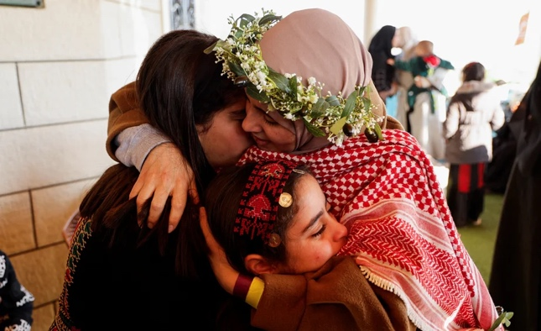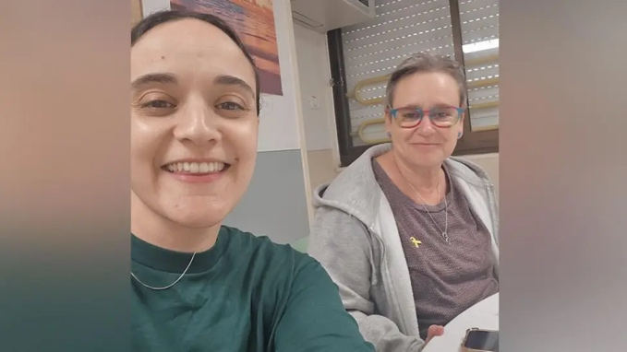

We held in our thoughts the joy of the returned hostages, in Gaza and in Israel –
But also witnessed the grief of Hanan AlQidra and her family, whose husband, 16-year-old son Adly and 6-year-old daughter Sama were killed when their donkey cart was bombed. Daughters Yasmin 12, and Aleel 8 and son Mohammed 11 survived.

ACT
No apologies that the main action this week is once again pressing for the release of Dr. Abu Safiya. We learn from an interview with his wife Albina on 972 that he is now in Ofer prison on the West Bank, should be meeting with his lawyer on 22nd Jan. and detention has been extended to Feb. 13th . Who knows – but it is likely that international pressure has helped with these changes.

Sign this RECENT petition from Amnesty NB click on the button TAKE ACTION
This is directed to Brigadier General Yifat Tomer Yersushalmi, the Miltary Advocate General responsible for implementing the rule of law in the IDF. Interesting woman.

LEARN: Ceasefire
We discussed the confusion around the ceasefire announcement, and who was responsible for the delay.
- Israelis: Hamas had not sent over the names of the 3 captives who would be released.
- Hamas: technical reasons for the delay, explained here as Hamas no longer using mobile phones (for obvious reasons), so communications are slower.
- According to Sqwawkbox, at the last minute, Netanyahu demanded the full list, not originally due to be provided until Stage 2 of the process. Yesterday evening a post showed that Israel has already violated the ceasefire by killing 3 people in Rafah including a 3-year-old, directly targeted by a sniper. Remember this.

LEARN: Rally on January 19th; What really happened
Several of us were present on Saturday. Both the Metropolitan Police and Guardian, misrepresented the events. The BBC website was balanced.
The reality is reported by the Palestine Solidarity Campaign. JVL, and Skwawkbox, where a video clearly shows police allowing protestors through to lay flowers in Trafalgar Square. Ben Jamal (PSC) and Chris Nineham (Stop the War Coalition) have been charged, along with several others. Read more about why this matters below in Annex 1

UPCOMING EVENTS
- Mustafa Barghouti, General Secretary of the Palestine National Initiative, Palestine - the struggle for justice in 2025
Online, THIS TUESDAY, Jan. 21 2025, 18.30 UK time. Register here // FB share here // RT here

- All Faiths All Ethnicities for Palestine (AFAEP) Saturday 25th January at noon, in Parliament Square – remembering all genocide survivors. This group formed out of the banned Christmas carol singing. To join their Whatsapp, ‎open this link

- PSC AGM Saturday February 1st 9.30-4.30pm. in person only at Red Lion Square London. CAMPAIN suggests supporting a motion put forward by Camden PSC.

JUST NEXT WEEK JANUARY 27th
Prosecuting war crimes: remembering Hind Rajab; the work of the Hind Rajab Foundation
The Holocaust – Never Again for Anyone…if you would like to lead reflections on this topic, please email Nicola at actionhourcampain@gmail.com

ANNEX 1. Why we need to pay attention to the policing of protests
Palestinian speakers at the rally were clear that worldwide protests have a huge impact, providing both support and pressure for change. All speakers were clear that protests need to continue to achieve justice and freedom for Palestine. It was also obvious that police tactics changed dramatically with far more draconian measures adopted, and inconsistent and troubling restrictions (Nicola Grove was told to remove a photograph of dead children from a poster as it was offensive and she could be arrested for inciting disorder). Adam Slonecki, the Met Commander for Strategy and Transformation, claims that This is the highest number of arrests we have seen, in response to the most significant escalation in criminality.

There was no criminal behaviour; the protest was as orderly and good-humoured as ever. Miranda Pinch said My other observation is that the restrictions were placed on us because of a powerful minority of Jews. I stood and walked with many other Jews who wanted to be there, felt perfectly safe and were horrified by those who were trying to stop us. We really do need to act on such undemocratic and pro-Israeli restrictions to our liberty and freedom of expression.
Difficult to complain if you were not there, but here are the relevant addresses:
- Police Conduct Authority
https://www.policeconduct.gov.uk/complaints/submit-a-complaint
- Met
enquiries@mpa.gov.uk
- Chief constable
mark.rowley@met.police.uk
- Adam Slonecki Commander (Strategy and Transformation)
Adam.Slonecki@met.police.uk
- Sadiq Khan
mayor@london.gov.uk
Keir Starmer.mp@parliament.uk

Annex 2 Social media news
- Let’s Talk Palestine - a podcast available on Spotify, and also @letstalkpalestine on Instagram NB Let’s Talk Palestine originally claimed that the ceasefire would be in operation 10-12 h only, but have since corrected this. However, one of our members recommends this site.
- WhatsApp is apparently sharing data with the IDF, though we don’t know much about this.

